Hydrocarbon Exploration using Seismic Images
Abhishek Varma, Aman Gupta, Dylan Saldanha
Computer Science and Engineering Department, Sapthagiri College of Engineering (VTU)
Bangalore, India
abhishekvarma16@gmail.com
aman.iv0012@gmail.com
dylxn@protonmail.com

Abstract— Seismic-data interpretation has as it’s main goal the identification of compartments, faults, fault sealing, and trapping mechanism that hold hydrocarbons; it additionally tries to understand the depositional history of the environment to describe the relationship between seismic data and a priori geological information. Imaging salt has been a huge topic in the seismic industry, basically since they imaged salt the first time. The Society of Exploration geophysicist alone has over 10,000 publications with the keyword salt. Salt bodies are important for the hydrocarbon industry, as they usually form nice oil traps. So there's a clear motivation to delineate salt bodies in the subsurface. Seismic data interpreters are used to interpreting on 2D or 3D images that have been heavily processed. In our problem statement we our dealing with data that is less noisy which is an added advantage. Our solution to the problem is to basically use U-Net. The energy function is computed by a pixel-wise soft-max over the final feature map combined with the cross entropy loss function.
Keywords—U-Nets, CNN, hydrocarbon exploration, salt body identification.

Introduction (Heading 1)
Acquisition technology advances and exploration of complex areas are pushing the amount of data to be analyzed into the “big data” category. Current exploration workflows consist of many partially automated steps in which domain experts (geologists, geophysicists, rock physicists, etc.) command highly tuned applications and then curate the resulting data in search of valuable information. The data explosion is stressing these workflows to a point at which every year more of the data remains unused. Generally, the exploration process can be broken down into two main elements: advanced tools and manpower. Tools have progressed, and the addition of high-performance computing has helped to reduce turnaround times for seismic imaging [1]. Even in the extreme case in which execution time for processing tools would take nearly zero time, the problem of manpower remains; there is no sensible way in which domain experts can analyze and interpret all incoming data. The best solution must trade domain-expert time for computing time. Therefore, some of that domain knowledge needs to be formalized and implemented within existing and future tools. One way to achieve this is by taking advantage of algorithms that learn, for instance, from legacy data that have been properly vetted. Using machine learning, we can take advantage of new algorithms and software ecosystems, as well as specialized hardware. In this contribution, we will focus our attention on one such application of machine learning.
Seismic imaging is the primary tool used to build high-resolution models of the subsurface. In practice, it is typically part of an iterative workflow that alternates between imaging steps and model update steps. This iterative refinement is expensive in terms of human costs (picking out features/adjusting the velocity model) and computational costs (many repeated wave propagations and attributes computations). Most prior work focused on identifying features in already migrated image [2] [3]. The literature is filled with refinements to this workflow, but ultimately, it remains largely the same.

Related Work

Supervised learning to detect salt body
Seismic-data interpretation has as its main goal the identification of compartments, faults, fault sealing, and trapping mechanism that hold hydrocarbons; it additionally tries to understand the depositional history of the environment to describe the relationship between seismic data and a priori geological information. Data mining or knowledge discovery in databases (KDD) has become a significant area both in academia and industry. Data mining is the process of extracting novel, useful and understandable patterns from a large collection of data.
A major strategy in this field is to apply data mining algorithms (Hastie, 2011) to classify points or parts of the 3D seismic data to reinforce correct data interpretations. Multiple studies have shown the benefits of using data mining techniques for seismic-data interpretation. For example, previous work has shown how to generate a set of seismic traces from velocity models containing faults with varying locality, using machine learning to identify the presence of a fault in previously unseen traces (Zhang et. al., 2014). Other techniques segment a seismic image into structural and stratigraphic geologic units (Hale, 2002), which is best done using global optimization methods (Shi et. al., 2000; Hale et. al., 2003). Another solution is to use unsupervised learning techniques (Coléou et. al., 2003), often relying on the application of Self Organizing Maps (Castro de Matos et. al., 2007). Our new approach is essentially a novel salt body detection workflow. The workflow as a whole envisions the creation of a software solution that can automatically identify, classify and delineate salt bodies from seismic data using seismic attributes and supervised learning algorithms.

Automated classification of salt bodies using machine learning
The approach aims at automatically identifying and delineating geological elements from seismic data. Specifically, we focus on the automatic classification of salt bodies using supervised learning techniques. In supervised learning we assume each element of study is represented as an n-component vector-valued random variable (X1 , X2 ,..,Xn ), where each Xi represents an attribute or feature; the space of all possible feature vectors is called the input space X. We also consider a set {w1, w2,...,wk} corresponding to the possible classes; this forms the output space W. A classifier or learning algorithm typically receives as input a set of training examples from a source domain, T = {(xi, wi)}, where x = (x1 , x2 ,…,xn ) is a vector in the input space, and w is a value in the (discrete) output space.
They assume the training or source sample T consists of independently and identically distributed (i.i.d.) examples obtained according to a fixed but unknown joint probability distribution, P(x,w), in the input-output space. The outcome of the classifier is a hypothesis or function f(x) mapping the input space to the output space, f: X → W. We commonly choose the hypothesis that minimizes the expected value of a loss function (e.g., zero-one loss).

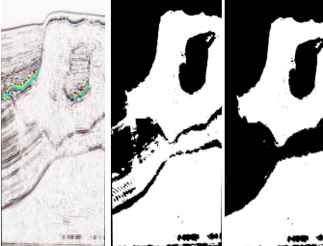
FIGURE 1: (a) Seismic Data(b)Classified Image(c)Results after post-processing step

Informative attributes to generate predictive models in seismic data
A proper characterization of voxels can be attained with useful and informative features. We selected three features for our study exhibiting high correlation with the target class: signal amplitude (directly from seismic data), second derivative, and curve length; the last two derived from amplitude. Second derivative is instrumental to detect edges in images, and curve length capture patterns which characterize different features observed inside a salt structure and in its surroundings.
Supervised learning algorithms
Our data analysis phase receives as input a body of seismic data with the task of automatically identifying salt regions. To achieve a class-balanced problem, we made sure exactly one half of the subset corresponded to salt, and the other half as non-salt (the task exhibited equal class priors). The model was built using 2 million training voxels. Accuracy is estimated using 10-fold cross validation (Hastie, 2011). The classification model was subsequently used to automatically label the entire body of seismic data (376,752,501 voxels).
Top performing learning algorithms were the following: Gradient Boosting Trees (Accuracy 80%), Extremely Randomized Trees (Accuracy 80%), and Random Forests (Accuracy 79%). All our learning algorithms are ensemble methods; these techniques have shown remarkable performance due to their ability to attain low bias (using complex decision boundaries), and low variance (achieved by averaging over various models).
SEAM I (SEG Advance Modeling Corporation) data, this comes from marine acquisition and represents strong challenges to the geophysical community. Inspiration was deep water (600 – 2000 meters) US GOM Salt Structure and its major structural features are salt body with rugose top and overhangs, twelves radial faults near the root salt, overturned sediment raft proximate to salt root and internal sutures and a heterogeneous salt cap. The migrated seismic volume was obtained with very low frequency, and there are sediments locations with similar amplitude value than salt body. Our final predictive model of choice was Extremely Randomized Trees, which was used to predict the labels of 376,752,501 samples; this resulted in a Boolean mask. The accuracy reported was essentially the same as in cross validation (80%). After that, we have removed outliers and misclassification using mathematical morphological operations and a 3D interactive guided (manual intervention) tool developed in house; finally, we used threshold segmentation using local average threshold to get better detection results.

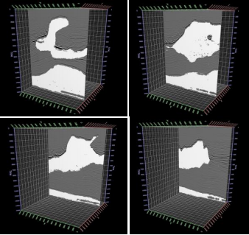
FIGURE 2: Overlapping between seismic data and salt body detected

To measure accuracy, we count the number of hits between the detected salt body and the interpretation in the following way: using both volumes, we have counted the number of hits voxel by voxel. We refer to this number as NH. The effectiveness ratio is calculated as: (NH/TS) * 100, where TS is the total number of voxels in the volume. Following this technique, we have obtained an accuracy of 95.22%.
Results show very high accuracy when machine learning algorithms are used to predict class labels of voxels on a seismic cube; this is true even after training with a very small portion of the data (0.5%). After a first step, where machine learning is applied directly to the data, we obtained accuracy values of around 80%. A second (post-processing) step increased accuracy to around 95%. We conclude that machine learning is a promising mechanism to identify geological bodies on seismic data when the selected model has high capacity, and is able to control the variance component of error by model averaging (using ensemble techniques).

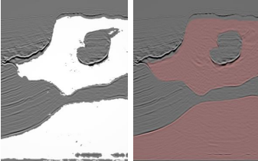
FIGURE 3:Overlapping between seismic data (a) salt body data (b) interpretation

Automated Fault Detection Without Seismic Processing
Recent work [4] demonstrates a new approach that builds and uses a deep neural network (DNN) statistical model to transform raw-input seismic data directly to the final mapping of faults in 2D. In this case, fault locations were chosen as the output because of their relevance to optimizing production in existing fields. DNNs are built on the premise that they can be used to replicate any function. This paper shows that DNNs can be used to identify fault structure in 3D volumes with reasonable accuracy.
The first step in Reference 5's workflow (Figure 4) is to collect the training examples. Real data examples are impractical and limiting since the labels are assigned to fault locations by few domain experts. This means that the neural network’s best result would be bound by human performance and data quality. Instead, the idea here is to generate realistic 3D velocity models synthetically, with the fault labeling generated concurrently for an unbiased ground truth. Next, they use an acoustic approximation to the wave equation to generate wave fields and record them as time-series signals with predefined acquisition geometry. This step is conducted on thousands of random velocity-model realizations, giving many instances of labeled fault locations and the corresponding seismic traces for the entire data set. A portion of this data set is kept unseen from the algorithm (holdout set) so that it can be used for testing after training the predictor. Ranges have been set on a relatively small number of parameters as bounds on the random model generator. These parameters include the number of layers in a model, the number of faults, the range of velocity, and the dip and strike angles for each possible fault. It is believed by the authors that the randomized models produced in this manner are realistic enough to demonstrate the efficacy of neural network predictions (Figure 4)

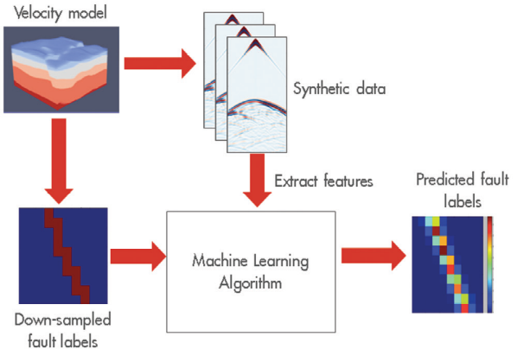
FIGURE 4:. Depiction of the workflow’s main tasks
Since the positions of the faults are known a priori, the labeling process is straightforward. However, complexity is added to this process when the labeling targets a subsampled grid for computational efficiency. Addition of a threshold parameter to define the labeling of the coarse grid is needed. This threshold value sets how many fine-sampled voxels inside a coarse voxel must be fault-labeled for that coarse voxel to be considered as having a fault or not. The threshold is chosen on a trial-and-error basis prior to any training. Raw seismic data is far too unrefined and redundant to be immediately useful as inputs to this neural network. The prediction performance is improved by extracting input features carefully, taking advantage of techniques from signal processing. The amount of collected features is large and grows by orders of magnitude when more realistic models are used.
The authors have generated thousands of random velocity models with up to four faults in them, of varying strike, dip angle, and position. Their models had between three and six layers each, with velocities varying from 2000 to 4000 [m/s], with layer velocity increasing with depth. These models were 140 × 180 × 180 grid points at the sampling used for wave propagation (using the acquisition geometry described earlier) but were subsampled to 20 × 20 × 20 and 32 × 32 × 32 for labeling purposes. The raw data collected was reduced aggressively to a feature set that can fit in an NVIDIA K80 GPGPU memory.
With the generated features and labels, a variety of fully connected deep neural networks are trained. The network architecture main parameters varied from two to 20 hidden layers and 256 to 2048 units per layer. For all cases presented in Table 1, they used the Wasserstein loss function for training. The output of the networks is a subsampled 3D voxel grid, with each voxel’s value indicating the likelihood of a fault being present within the voxel. Ground-truth labels on the same grid were binary valued, indicating presence or not of a fault in each voxel. The final predictions were generated by taking the likelihood values map output and applying a threshold to it, such that likelihood values above the threshold would be considered having a fault, while those below would not. As a result, a lower threshold will label more voxels as faults, while a high threshold labels less.
Here two different quantitative metrics of performance are used: intersection over union (IoU) and area under the ROC curve (AUC).
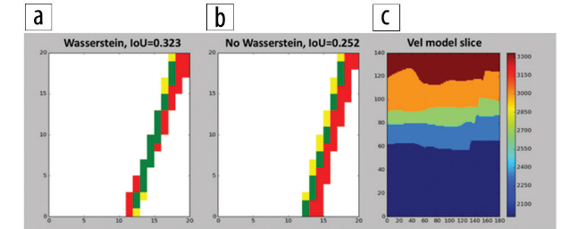
FIGURE 5: Comparison of (a) the Wasserstein- and (b) non-Wasserstein-based predictions, IoU metric (described in the article). Red areas show false positives, green shows true positives (correct predictions), and yellow shows false negative. (c) 2D slice of a 3D model. The predictions have very different IoU, where green means better.

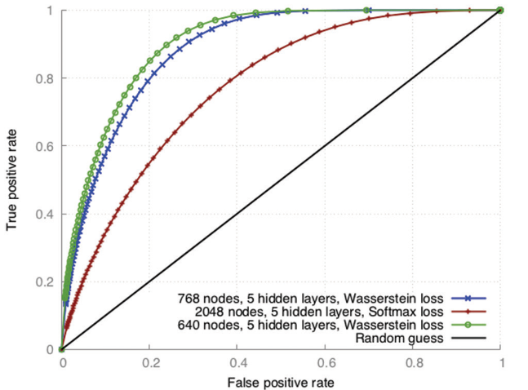
FIGURE 6: ROC curves for representative DNN architectures. The closer to the top-left corner the better.

The IoU value is a ratio of the number of voxels that are in the intersection of the ground truth and prediction, divided by the number of voxels in the union of the ground truth and prediction. This gives us an idea of how clustered or scattered a prediction is; the values range from 0 to 1, where higher values are better (Figure 5). Two predictions could theoretically have the same AUC value (Table 1) but different IoU values. The (IoU) value averaged for the entire test set of predictions, with predicted likelihoods thresholded at a value chosen to maximize the average IoU over all the predictions.
Each point of a receiver operating characteristics (ROC) curve (Figure 6) is based on the number of true positive predictions (vertical axis) and the false positive predictions (horizontal axis) for a particular threshold value. The AUC for the predictions, which describes how strong our predictor is. The value ranges from 0.5 to 1.0, where the higher the value the better.
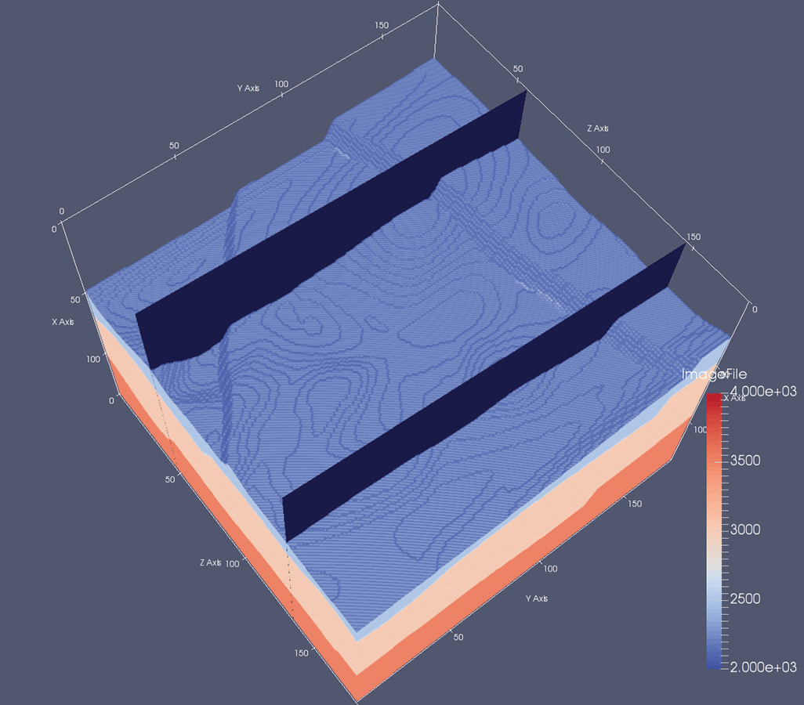
FIGURE 7: Example of 3D model with two 2D highlighted slices. In this top view, two faults can be identified.

TABLE 1: Results obtained on several representative sets of simulated test data. The first two columns report performance metrics; the other columns describe the parameter of the experiments. All results obtained using Wasserstein loss function, with 16,000 training models and 4000 testing models.
1024 | IoU | Hidden Layers | Nodes per Layer | Faults per Model
0.902 | 0.311 | 5 | 768 | 4
0.893 | 0.294 | 5 | 640 | 4
0.836 | 0.220 | 7 | 640 | 4
0.833 | 0.218 | 8 | 512 | 4
0.854 | 0.246 | 7 | 512 | 2
0.849 | 0.227 | 6 | 512 | 2
0.820 | 0.219 | 6 | 512 | 2
0.718 | 0.130 | 4 | 1024 | 1
0.897 | 0.395 | 4 | 512 | 1
0.919 | 0.384 | 4 | 256 | 1
In Table 1, for all data sets (one, two, and four faults in model) AUC exceeds 0.9, which approaches that needed for practical use. Also, IoU surpasses 0.3 for many experiments, which implies that the prediction can be improved in terms of spatial alignment with respect to the ground truth. The prediction grid size of experiments in Fig. 9 is 32 × 32 × 32, therefore each prediction represents a voxel of 4 × 5 × 5 in the model space.
The predictions in Figure 9 follow the expected results, plus some false positives in the bottom-right area of the back slice. However, false positives are present in the area where the faults coincide. This is in line with expectations, since a cornucopia of signals and patterns are produced in that area. This case exposes the current limit of the author's predicting resolution for complex cases. In general, the resolution is limited by the quality of the data.
To evaluate practical usability, we must address how this approach can be scaled to actual production-level seismic data sets. Current synthetic input data is based on fixed acquisition geometry. If we use this fixed geometry to train a predictor, one must bin and stack the acquired data so that it matches the acquisition used for training the model. For this reason, we believe that using a fixed dense geometry permits us to accurately bin and stack real data to match the predictor’s input parameters. Denser acquisition means more features, and as a result, more dramatic reduction of the feature space (and/or more complex neural networks) is needed.
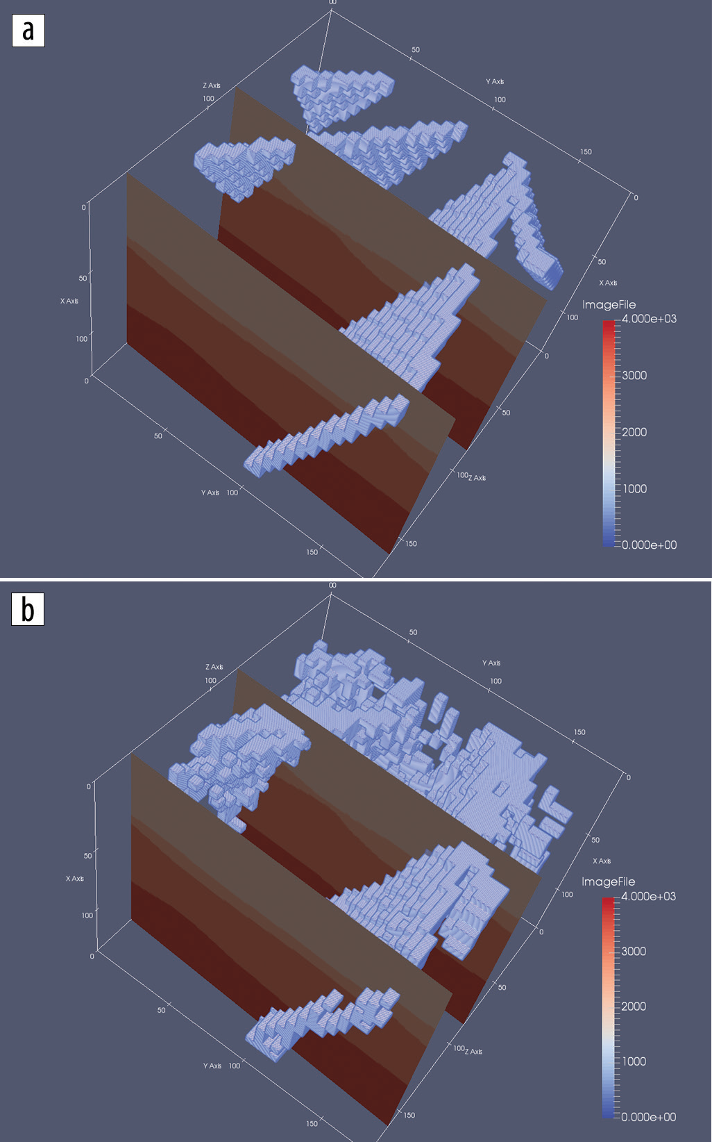
FIGURE 9: (a) Expected predictions for fault network in Figure 8 velocity model slices. (b) Author’s DDN-based predictions.

Another area where it can improve the prediction quality is by increasing the number of voxels in our downsampled output grid such that we have better resolution in our predictions. This increase in voxel granularity means a more computationally demanding neural network and thus an increase in the cost of tuning and training.
This workflow is flexible with respect to what can be predicted. The workflow can be repurposed to build one that predicts, for instance, salt bodies instead of fault locations. It is easy to change the labeling scheme so that salt bodies are labeled before training. Since salt bodies often create strong signals (at least for the top-of-salt events) it can be expected that this geologic feature could also be identified using this method. Preliminary results along this line are promising.

Automatic salt-body classification using deep-convolutional neural network
In this paper an alternative network architecture inspired by Segnet and U-Net ,that overcomes the problem by learning to map encoder outputs to final classification labels of image dimension.The architecure used here is composed of a stack of encoder followed by a corresponding decoder stack stack which feeds into a softmax classification layer. Both the encoder and decoder are fully convolutional layers.The salt body labels are generated automatically with the aid of automatic tools.
The network is first trained on selected 2D slices,then the model is validated by predicting salt body location on other unseen slices.
Here the salt body classification is treated as a semantic image segmentation problem with binary classes: the algorithm assigns a salt label to each image pixel based on the shape of the seismic image. While multiple seismic attributes can aid the salt body detection, for simplicity, we only use seismic amplitude as the input in our automated method.The network has the ability to delineate objects based on their shape despite their small size. Compared to previous network architectures, this encoder-decoder architecture can be trained end-to-end in order to jointly optimize all the model parameters in the network. The key component of our proposed network is the decoder network which consists of a hierarchy of decoders corresponding to each encoder. The original Segnet reuses the max-pooling indices received from the encoders to perform non-linear up sampling of decoder feature maps, but this type of up sampling is prone to checkerboard artifacts (Odena et al., 2016).While these artifacts are acceptable in normal scale natural images,the issue becomes significant in seismic images which contain small scale features such as reflection signals, faults and tiny discontinuities. To overcome this issue, we adopt the resize convolution proposed by Odena et al. (2016) in our implementation. Each encoder in the encoder network performs convolution with a filter bank to produce a set of feature maps. These are then regularized by batch normalization (Ioffe and Szegedy,2015). Element-wise rectified-linear unit (σ(x) = max {0, x}) is applied as non-linear activation. Following that, we perform max-pooling and the resulting output is sub-sampled by a factor of 2. Max-pooling achieves translation invariance over small spatial shifts in the input image. The appropriate decoder in the decoder network up samples its input feature maps by resizing-interpolation. This step produces sparse feature maps which are convolved with a trainable decoder filter bank to produce dense feature maps. Batch normalizations are also applied. The high dimensional feature representation at the output of the final decoder is fed to a trainable softmax classifier. The output of the classifier is a K channel image of classification probabilities, where K is the number of classes. The k value is set to 2 where pixels are classified as inside/outside salt body.
Training process used here:
We train and test the network using SEAM Phase 1 dataset. This dataset contains a 3D seismic volume which a salt body exists in the middle. We use the 2D single-channel seismic amplitude data as our input to the network. The challenge is to identify the salt body, from a noisy seismic image. The network can only learn from the subtle features such as high reflectivity and largely dipped boundary. We selected 8 crossline 2D slices as training data. The training labels are manual annotations generated by optimal path picking method (Wu et al., 2017). Before each epoch, the training set is shuffled. Compared to the size of the model, this is a fairly small dataset; however, the bottleneck architecture ensures that essential relationship are captured. The model weights, or parameters, are initialized using the technique described in He et al. (2015). We use the cross-entropy loss as the objective function, and adaptive momentum descent (Adam) as optimization algorithm (Kingma and Ba, 2014) to iteratively update the model weights. After 200 epochs of training, the model achieves 98.77% global accuracy (the percentage of pixels correctly classified in the image). The figure here shows the training results of selected data samples. The salt likelihood is the probability output of the softmax classifier, and the predictions are assigned by max-likelihood class. Compared to the ground truth, the training accuracy is nearly as good as the human interpretation.
The input and output shapes are listed in the format: [samples number, image height, image width, channels number]. All samples numbers are not fixed in the network since multiple data samples can run in parallel. Note that the initial input image has 1 channel (seismic amplitude) and the final output has 2 channels (binary classification).The intermediate channels represent multiple feature maps.
Validation Tests
We first test the performance of the trained model at different crossline slices. Figure 3 shows the network output of these unseen crossline slices. Since these slices are still crossline slices, they share some similar features with the training data.
It is noticeable that some noisy artifacts appear as “holes” in the detected salt body; however, the global shape of the salt body is extracted accurately, especially on the top boundary of the salt. To visualize the result, we extract the top salt locations with > 0:6 classification probability. The right column in the figure clearly shows these top salt boundaries match seismic amplitudes accurately.

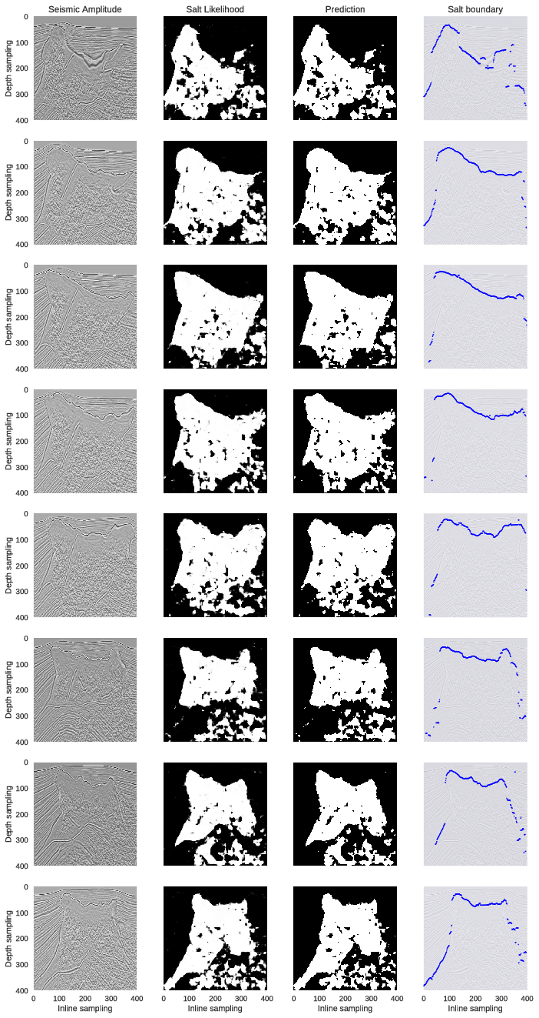
FIGURE 10:
We then test the model on inline slices. The inline slices consists of images significantly different from the training set. The performance on this test can imply whether the network successfully learn important features independently to the view perspective. Figure 4 shows the network outputs of these inline slices. The first row of Figure 4 only contains a salt intrusion at the bottom-left corner, but the network seems to falsely classify some of the horizontal reflections as salt. The second to the seventh rows show that the salt bodies are correctly detected; however, the deeper parts of the images where seismic. The 8 rows represent 8 crossline samples extracted at inline locations different from the ones used in training set: [25, 75, 125, 175, 225, 275, 325,375]. From left to right, the first column show seismic amplitude images; the second column show probability outputs from softmax classifier of the network; the third column show salt detection prediction results generated by max-likelihood class; the fourth column show top salt boundaries by extracting
the first occurence of salt likelihood > 0:6.Images are more noisy are incorrectly assigned to salt body. The eighth row shows that although deeper image part suffers from noise, the salt body in the shallow part is still correctly delineated. Except for the first row example, all examples show good detections of the top boundary of the salt body.
Based on these results, we conclude that the proposed method can generalize well even when trained with only small dataset; the top boundary detection is the most robust prediction by the network.
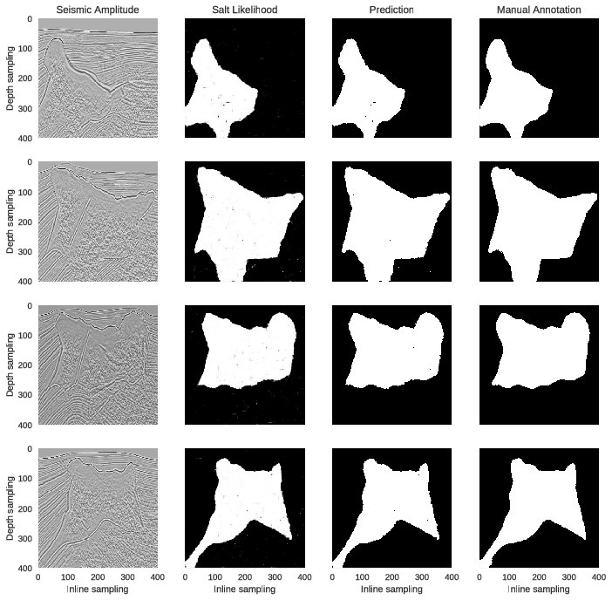
FIGURE 11:

Conclusion
We present a novel approach to the challenging multistep seismic model-building problem. It uses a deep learning system to map out a salt body in the sub surface, using raw seismic recordings as input. A distinguishing aspect of the solution is the use of the Wasserstein loss function, which is suited to problems in which the outputs have spatial layout dependency. We demonstrate the system’s performance on real world data sets with complex salt body formations. The primary challenge going forward will be transitioning to salt bodies with more complex 3D geometry. This will lead to more tuned existing networks and/or extensions to our workflows.
The application of machine learning approaches to seismic imaging and interpretation shows great promise in hydrocarbon exploration and can dramatically change how the vast amount of seismic data is used in the future.

References
- Rastogi, R., 2011, High performance computing in seismic data processing: Promises and challenges: Presented at HPC Advisory Council Switzerland Workshop 2011, http://www.hpcadvisorycouncil.com/events/2011/switzerland_workshop/pdf/Presentations/Day%203/2_CDAC.pdf, accessed 16 January 2017.
- Shi, Yunzhi & wu, Xinming & Fomel, Sergey. (2018). Automatic salt-body classification using deep-convolutional neural network. 10.1190/segam2018-2997304.1.
- Guillen, Pablo & Larrazabal, German & Gonzalez, Gladys & Boumber, Dainis & Vilalta, Ricardo. (2015). Supervised learning to detect salt body.
- Frogner, C., C. Zhang, H. Mobahi, M. Araya-Polo, and T. A. Poggio, 2015, Learning with a Wasserstein loss: Presented at Advances in Neural Information Processing Systems (NIPS) 28.
- Araya-Polo, Mauricio, Taylor Dahlke, Charlie Frogner, Chiyuan Zhang, Tomaso Poggio, and Detlef Hohl. “Automated Fault Detection Without Seismic Processing.” The Leading Edge 36, no. 3 (March 2017): 208–214 © 2017 Society of Exploration Geophysicists
- Khan, Asifullah. (2016). Introduction to Deep Convolutional Neural Networks.
- Ronneberger, Olaf & Fischer, Philipp & Brox, Thomas. (2015). U-Net: Convolutional Networks for Biomedical Image Segmentation. LNCS. 9351. 234-241. 10.1007/978-3-319-24574-4_28.
- Dahlke, T., M. Araya-Polo, C. Zhang, and C. Frogner, 2016, Predicting geological features in 3D Seismic Data: Presented at Advances in Neural Information Processing Systems (NIPS) 29, 3D Deep Learning Workshop.
- Lin, H., and M. Tegmark, 2016, Why does deep and cheap learning work so well?: arXiv:1608.08225.

